Econometric Analysis Paper
Applied Econometrics 2
Dr. Fadi Fawaz
12/15/2024

Description
My research question attempts to address the potential link between economic performance variables (median income) with health disease mortality rates for the selected years 2020,2021,2022 and cumulatively since 2020. With this, I want to look at 2020 and post pandemic effects on potential health inequalities pooled by state as well as trend effects during and after the pandemic. This question is relevant to the study of economics in that if there appears to be a significant link between median incomes and heart disease mortality rates, then economic, educational and other policy prescriptions could serve as a mitigation to these effects. Additionally, heart disease is the leading cause of death in the United States. (Healthy People 30 , 2018) Education services and possible economic policy prescriptions could save significant healthcare costs and workplace productivity. Also, through understanding of these relationships, businesses could develop strategies and policies to ensure health indicators are addressed and monitored in employees to better productivity. A compelling example of these effects are expressed in data analyses that shows that lower income states (i.e Mississippi) report significantly more heart disease mortality rates than higher income states like Massachusetts etc. (Mendy, 2022) With this, this analysis could be used to see how the Covid-19 pandemic as well as its passing have significantly affected economic performance and income and analyze how this has had a profound effect (if any) on subsequently listed states and trends.
Target Audiences and Implications
This paper will include both technical and non-technical readers. For the technical audience, literature reviews and methodologies will provide policymakers, economists and statisticians with insights to make informed decisions based upon rigorous statistical analysis as well as vital jargon on understanding relationships and interaction effects of variables. For this level of expertise, analyses of these relationships could be used to help inform decisionmakers and help target potential intervention and policy. For economists and statisticians, findings could provide ample critique and stimulation for more potential research. In addition, providing comprehensive conclusions, takeaways and recommendations will allow non-technical readers, like the public and policymakers, to discuss and reference for public use. This audience could use this analysis to foster community actions or even generate potential discusses to help educate business or everyday citizens of economic effects on health.
Literature Review
There have been several interesting studies attempting to provide a causal link between economic and health variables in the literature. One very interesting study done in the United States focused on casual mediation analysis and record link data to look at socioeconomic inequalities and Ischemic Heart Disease Mortalities in the United States. The conductors of the study obtained data from the National Health Interview Survey with mortalities following up till December 31, 2019. 524,035 individuals aged 25 and older were followed for approximately 10 years resulting in 13,256 IHD (ischemic heart disease) deaths followed. Then, 4 BFR (Behavior Risk Factors) were used including smoking, alcohol use, physical inactivity, and BMI (Body Mass Index) to socioeconomic statuses. Education was the primary indicator for socioeconomic status. (Zhu et al., 2024) Econometrically, counterfactual causal mediation and Cox proportional hazards models were used to access if any direct and indirect effects occurred between people of higher socio-economic status and lower statues holding BFR’s similar. These counterfactuals are like “what if” situations in which we want to see what would happen to IHD provided we include these BFR factors as well as look at effects of socio-economic status. Cox time to event analysis allowed researchers to look at direct effects of SES and indirect effects that BFR’s might have had on ischemic heart disease mortality. (Zhu et al., 2024) For these situations in which indirect effects are analyzed and time to event data is accessed, these models were highly useful for determining mediated effects on ischemic heart disease mortality. Various forms of regression would fall short for this type of study in a variety of ways. Primarily, simple regressions assume linearity (which is hardly ever the case) and additionally, regression models do not account for mediating variables. These mediating effects show how socio-economic statuses are affected though indirect channels listed in the BFR’s not simply listed as an interaction or direct effect to the dependent variable of ischemic heart disease mortality. Also, time to event data is better handled by the cox models in that morality risk changes over time and proportional hazard are better equipped at handling this dynamic over time. (LaMorte, 2016)
Another interesting method and technique that was used to study a similar issue was performed by Xia et al., 2024. This study utilized a cohort design of 26,000 participants and attempted to incorporate area-level determinants (education and income etc.) into risk prediction models for atherosclerotic cardiovascular disease (ASCVD). What the study aimed to explore was if adding individual or area level determinants of health to pooled cohort equations and predicting risks for cardiovascular disease improve accuracy of risk for atherosclerotic cardiovascular disease. (Xia et al., 2024) This study expounds in a way on the previous, but this time, included individual-level and area-level social determinants of health were added to Cox proportional models to help access cohort data and indirect effects on risk on CVD over time. (Xia et al., 2024) In this study, regression and Cox proportional models were both suitable and accurate for this study in that regression analysis was useful for looking at SDOH and CVD risk by area and individuals while Cox proportional modeling allowed for accessing time dependent risks and their influence.
One final study attempted to look at how SESs contributed to early coronary heart disease (CHD) in adults. They did this by looking at both blood pressure, cholesterol etc. and then examining other SES factors. However, computational models (Cardiovascular Disease Policy Models) were implemented by attempting to project progression of disease over time. They did this by dividing population into differing states. This could be categorized as healthy, at risk etc. Then, based upon probabilities discovered through epidemiological data, the researchers could simulate how coronary heart disease could develop across a population. (Hamad et al., 2020) For this, regression analysis would not be appropriate because it cannot account for transitions over a simulated lifetime with modeling dynamic health issue states etc.
Hypothesis
For my study, the null hypothesis will be, “There is no statistically significant relationship between median income and heart disease mortality rates across selected states in 2020, 2021, 2022, and since 2020 to 2022” Alternatively, “There exists a statistically significant relationship between median income and heart disease mortality rates across selected states in 2020, 2021, 2022, and since 2020 to 2022.” I’ve included the 32-state sample in the references.
Translation into Models
For this hypothesis we can include the following model.
Heart Disease Mortality Ratei,t​=αt​+βt​⋅Median Incomei,t​+ϵi,t. Here we can see that βt captures the impact on heart disease mortality for a single year in time with random error listed ϵi,t.
Secondly the panel data model will include:
Heart Disease Mortality Rate it​=α+β⋅Median Incomeit​+ γt​+ μi ​+ϵit​
Within this model, we can see that both time- fixed effects γt​ and state fixed effects μi will be used to account for year-specific changes as well as any unobservable state characteristics. (Schmelzer, 2024) With this we can look at how these relationships could potentially shift by year as well as captures changes from 2020 to 2022 to look broader, significant changes overtime. Here we can provide a means to begin looking into possible explanations for significant changes by year and time. Such variables could include Covid-19 and its potential economic effects. Simpler models are not appropriate in this study to the nature of panel data as well as the possibility of state specific heterogeneity and time specific factors and could lead to bias estimates in results. Also, interaction terms allow us to provide granular analysis into why effects are or are not happening as well as when are could potentially happen. Also, simple OLS was not employed for ultimate model due to extreme multicollinearity in results for multiple years and lack of granular trends in state and time effects and cross sectional, isolated observation. Fixed effect models allow for time invariant detail to see how the predictors effects have significant value. Additionally, time varying effects help determine external shocks significance and is superior to OLS in its detailed interactional effects by year.
Limitations to Ultimate Model and Data Limitations
One potential issue with my proposed model includes the limited time span (2020-2022) of the data set as well as sample size and generalizability. For example, it has been found in the literature that longer datasets in this type of analysis provide a capturing effect for cumulative as well as delayed effects for socioeconomic variables. (Wooldridge, 2010) Fixed effects may be affected empirically due to its fixation on short time span as opposed to larger trends that could be analyzed by other methods. Also, smaller sample sizes have been shown to reduce statistical power and propose more sensitivity to outliers. (Greene,2018) Presence of data measurement errors and outliers found and effect standard errors for empirical approach. With interactions between variables, we can see potential multicollinearity between Median Income and Educational Attainment could make effect hard to determine. (Gujarati & Porter, 2009) Ridge analysis could help in keep multicollinearity in check. Interaction terms can also be come an issue as they can lead to the reduction of generalizability for our models. Alternative to this would be to provide theoretical reasons for interaction as well as possible parsimonious models for observation. Dynamic Panel models could be excellent to include lag effects for this analysis.
Specification of Model
Baseline specification will include HeartDiseaseMortalityi,t​=α+β⋅MedianIncomei,t​+γt​+ϵi,t​ expressing general trends in data set. This will then extend into year based effects as well as state based effects which will address through the following HeartDiseaseMortalityi,t​=α+β⋅MedianIncomei,t​+γt​+μi​+ϵi,t​. Interaction effects model will adhere to the following HeartDiseaseMortalityi,t​=α+β⋅MedianIncomei,t​+t=2021∑2022​δt​⋅(Predictori,t​×Yeart)+γt​+μi​+ϵi,t​. This allows me to look at overall year combined with variables to see dynamics. Cluster standard errors will be addressed to correct for autocorrelation and heteroskedasticity. (Angrist and Pischke, 2009) Transformations of variables were not used due to their natural linearity and dataset doesn’t show diminishing effects. Therefore, nonlinearity isn’t interpreted. (Greene ,2018) Linearity models will therefore be used and linearity will be justified though specific tests. This will rule out alternatives.
Data
I will use the following data for my analysis. For my first independent variable, I will be using data gleaned from the Federal Reserve Economic Data (FRED) as it pertains to median income and education level attainment by state for selected years 2020,2021,2022. (Federal Reserve Economic Data, n.d.-a) (Federal Reserve Economic Data, n.d.-b) This data is suitable due to its measure of socioeconomic status, allowing us to test if a significant relationship exists between a socio-economic marker and heart disease mortality rates. Also, educational attainment has positive correlations with health behaviors and resource attainment. (Telfair & Shelton, 2014) This could provide important information to aid in the robustness of our model and isolate median incomes effect on heart disease mortalities. The FRED culls excellent government resources on population data including Census Bureau, Bureau of Economic Analysis, and the National Center for Health Statistics. In addition, I will also be using CDC data, all of which use different methods such as questionaries, interviews, access to electronic health records as well as corporate financial and local government statements for standardization. (CDC, 2024) (CDC, 2024a) (CDC, 2024b)
Additionally, I will be using data taken from the CDC Behavioral Risk Factor Surveillance System (BRFSS) to look at heart disease mortality rates (Centers for Disease Control and Prevention, 2022), smokers’ status (defined as every day and somedays) (CDC, 2020b) and BMI (defined as obese 30.0-99.8) by state for the selected years 2020,2021,2022. (CDC, 2020) This is continuous, state-level data that has been collected are self-reported via random number sampling. In addition, specific weights and sampling techniques (graphical stratification, weights like sex, age, race as well as oversampling of key populations) are done to achieve accurate representation of the datasets included. (CDC, 2020b)

Bias
Some possible biases with data pulled from the CDC BRFSS lies in their reliability on self-reported data. Underreporting or inaccurate reporting could be a huge issue when trying accurately to assess certain variables for research. Also wording and understanding of questions is vital for information to be accurate and reliable. Also, nonresponse bias can create data issues in that non-respondents could differ from those that participate. (Ganassali, 2008) One example of this could be that health-conscious individuals may respond more to surveys thus skewing results. Also, data is collected annually which may miss seasonal or time variant fluctuations. (Kim et al., 2021)
The data contained in my FRED references could result in biases in data due to factors such as temporal lags for economic variables as GDP etc. that changes as new information becomes prevalent. Also, data aggregation and gaps in informal economic data can also present significant biases due to extrapolations and excluding other factors like bartering or undocumented work into analyses. (De Jong, Engelbert, & Brockmeier, 2014)
Data, Relationships and Implications
With median income and education attainment data from the FRED, we can see that both contain tables that show each state current, cross sectional year to be analyzed. Along with this, we can an also see that the Preceding Period and Year Ago from Periods listed next to the current year in question in the appropriate units. For example, educational attainment is expressed in continuous percentage of population sampled by state and median income is measured in CPI-U Dollars is also continuous data. (Federal Reserve Economic Data, n.d.-a) (Federal Reserve Economic Data, n.d.-b) From the CDC, we can see that prevalence data for obesity rates are expressed in bar graph formats with categorical BMI classification types ranging from underweight to obese. The operational definition of these categories lies in the ranges of BMI. For example, underweight expresses a BMI of 12.0-18.4 while Obese is expressed by 30.0-99.8. (CDC, 2020a) These classification types are then plotted to percentage of population for each state. Finally, under each classification we can see the respective total n population for the sample as well as the confidence intervals the CDC believes fall into each category.
Relationships and Implications
Based upon the selected 32 states in this study, several relationships were gleaned from a simple screening of the data. I took a small sample of about 5 states and here were the descriptive outputs and correlations. Also, I ran some simple correlations to see what relationships we could encounter down the line.
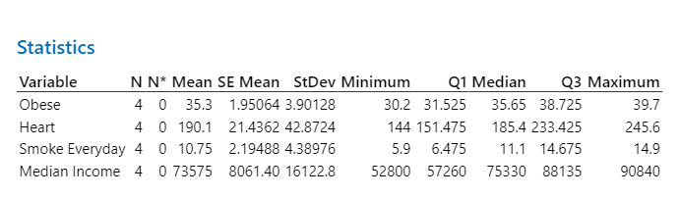
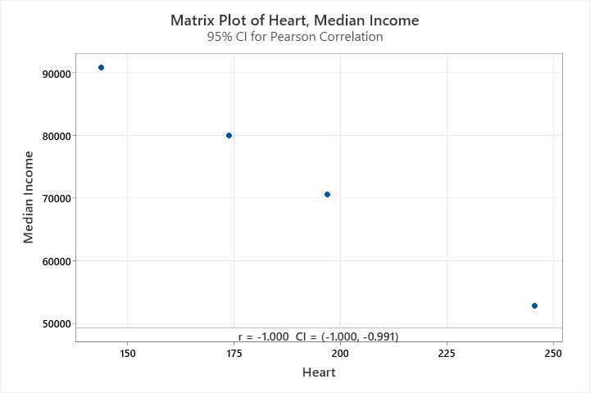

We should expect an inverse relationship of median income to heart disease mortality rates. This has been accessed in other studies (Joseph, 2021) but could indicate that there exists an inverse relationship of between median income and heart disease mortality rates which could imply that higher income states have better access to health care resources than lower income states and populations.
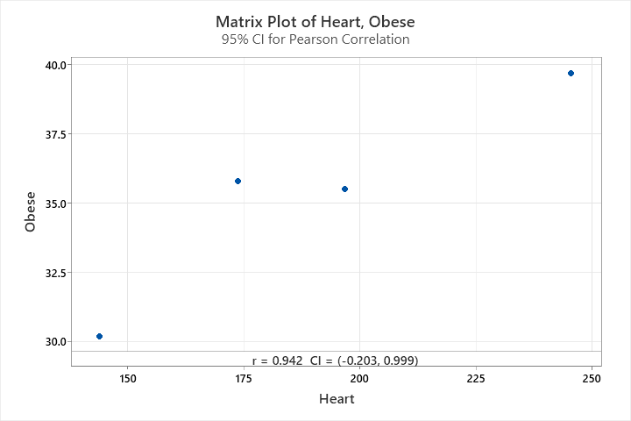
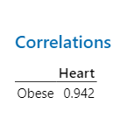
Once again here we can also see from the crude analysis that there is a positive relationship between obesity and heart disease mortality. Keep in mind this data set is too small for any conclusions to be made. However, this could point us in the direction of showing that lower income states could be influencing obesity. However, other confounding factors could be access to food, safe environments for exercise etc. An implication for this could be that addressing income conditions in these environments could prove helpful for overall heart health. As we will also look at obesity and its relationship with median incomes.
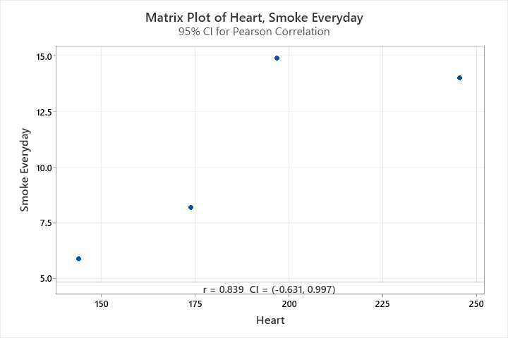
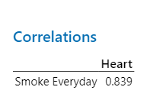
Here we see a positive relationship being formed for 2020 with smokers who smoke every day. This shouldn’t be too surprising; however, this can have the important effect outside of income. Reducing smoking of any kind has been shown to help with heart health and strategies and education to reduce smoking of any kind can provide significant aid to heart health and mortality. (Cole, 2019)
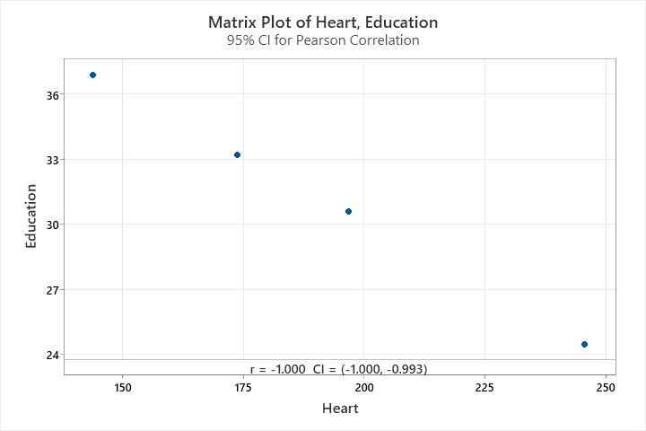
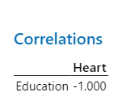
Here we can see that education is negatively correlated with heath disease mortality. This could be due to better access to healthcare resources as well as heathier lifestyle or health literacy This could imply that investing in education could help reduce health mortality by aware of heart health and lifestyle changes to aid in longevity.
Possible Influences and Misleading’s
Some major influences that could be producing misleading results are omitted variable bias, nonlinear relationships, measurement error and ecological fallacies. Primarily, if our model doesn’t account for healthcare access or urban vs rural relationships, this can create an incomplete relationship making income appear to be stronger than it actually is. Secondly, this simply crude analysis doesn’t tell us much more outside a small data set and linearity. If the relationships appear to be quadradic or logarithmic in nature, misrepresentation in dynamics can lead us to incorrect conclusions. Third is the way in which data is obtained and measured. Self-reported estimates come with ample biases (Althubaiti, 2016) and thus can skew and misrepresent relationships between variables. Lastly, aggregate data from by state takes the risks of lumping individual characteristics by placing them in state level aggregates. Drawing conclusions from state level data can distort or misaddress effect policy prescriptions and assessments. (Hansen & van Oorschot, 2020) Further analysis and more robust techniques will need to be done to reduce these effects.

Preliminary Results Baseline OLS
For our preliminary results we will take a pooled OLS test and interpret the baseline results to see if any interesting interactions are taking place.
OLS Regression Results
===================================================================================
Dep. Variable: Heart Disease Mortality R-squared: 0.337
Model: OLS Adj. R-squared: 0.298
Method: Least Squares F-statistic: 8.642
Date: Wed, 20 Nov 2024 Prob (F-statistic): 1.18e-06
Time: 16:24:59 Log-Likelihood: -431.03
No. Observations: 91 AIC: 874.1
Df Residuals: 85 BIC: 889.1
Df Model: 5
Covariance Type: nonrobust
========================================================================================
coef std err t P>|t| [0.025 0.975]
----------------------------------------------------------------------------------------
Constant 109.2981 65.620 1.666 0.099 -21.172 239.769
Median Income -0.0009 0.000 -2.101 0.039 -0.002 -4.61e-05
BMI 2.4152 1.141 2.116 0.037 0.146 4.684
Smoker Everyday (%) 3.7443 1.827 2.050 0.043 0.112 7.376
Smoker Somedays (%) -8.1433 5.391 -1.511 0.135 -18.862 2.576
Education Attainment 1.3549 0.747 1.813 0.073 -0.131 2.840
==============================================================================
Omnibus: 7.058 Durbin-Watson: 2.757
Prob(Omnibus): 0.029 Jarque-Bera (JB): 6.782
Skew: 0.517 Prob(JB): 0.0337
Kurtosis: 3.849 Cond. No. 1.79e+06
==============================================================================

Notes:
[1] Standard Errors assume that the covariance matrix of the errors is correctly specified.
[2] The condition number is large, 1.79e+06. This might indicate that there are
strong multicollinearity or other numerical problems.

Let’s begin by covering what these base results tell us about heart disease mortality and its relationship to our independent variables mentioned previously. Firstly we can see that are median incomes coefficient is -0.0009 and contains a significant p-value of 0.039. This indicates that with a 1000USD increase we can see a projected reduction in mortality by 0.9 per 100000 deaths. This significant relationship could be due to increased access to health care or lifestyles. Secondly, we see significant values in both BMI and Everyday Smokers. These values outputted at 2.415 (p-value 0.037) and 3.744 (p-value 0.043). This should be expected due to the fact that both BMI and Smoking have been significantly linked to a slew of health conditions and heart disease mortalities. (U.S. Department of Health and Human Services, 2020; World Health Organization, 2021) Next we find that that a interesting negative coefficient for sometime smokers at -8.143 (p-value 0.135) which indicates a higher proportion of occasional smokers to heart disease mortality reduction. Though this value is insignificant, it could be due to sampling variability or factors not included in our model. Finally, we see a statistically significant for educational attainment at 1.355 (p-value 0.073). This value shows that increasing education (bachelors) by one percentage point, results in approximately 1.36 additional death per 100,000. This should be aired on the side of caution as this result could be due to multicollinearity as well will see with this general model fit.
OLS Pooled Model Fitness and Relationship to Hypotheses
With this simple OLS regression, we can see that the R Squared value is expressed as 0.337. This shows us that 33.7 percent of the variance in heart disease mortalities are being explain by our model. This is a moderate level of explanation and other unobserved factors may be affecting mortality. (Gujarati & Porter, 2009; Wooldridge, 2010) The adjusted R Squared (0.298) which factors in the number of predictors drops this number to 29.8 percent explanation of the variance. Our F-Statistic shows us if the model collectively or jointly explains a significant portion of the variance in morality rates. We can see that the value represented shows 8.642 with a p-value of 0.001 meaning we have a significant model.
With this information there appears to be some support for the alternative hypothesis in that median income appears to have a significant effect against heart disease mortality and BMI and everyday smoking have statistically significant positive relationships with increased mortality rates as expected. However, it is counter intuitive to find that education levels are associated with increase in mortality rates. According to the literature we should see a education attainment linked with better health outcome variables due to health literacy and healhier life styles. (Cutler & Lleras-Muney, 2010; Grossman, 2006) This could be due to the multicollinearity between education and median income which was found in the pooled analysis. Also omitted variables to the ultimate model could also explain this counter intuition. Second is someday smokers. Any type of smoking is seen as a risk to mortality. (U.S. Department of Health and Human Services, 2020) However, the negative coefficient tells us that more occasional smoking corresponds to less heart disease mortality which we should expect. This issue could be due to the non-linearity in occasional smoking to every day smoking as well as confounders such as sates with lower smokers might have less mortality. We should also expect a higher R value, but this model is not our ultimate model which accounts for heterogeneity, endogeneity etc.
Differences in Baseline to Ultimate Model
This model does not address all the various violations (which will be discussed below) and issues that are ultimate model will have. Though we have included confounding variables, we have not shown any corrections to multicollinearity (expressed from the OLS model), autocorrelation, heteroskedasticity, endogeneity to correct the OLS model. Additionally, panel techniques have not been applied to look at the time-invariant and state-specific factors that could decrease our biases for the ultimate model. Additionally, interaction terms, nonlinear relationship test as well as additional controls and instrumentation need to be applied to help increase the robustness to our ultimate model. (Wooldridge, 2010; Angrist & Pischke, 2009)
Violations and Procedure
To proceed, will need to run a battery of test to check for OLS violations. After the results for multiple violations have been determined, we will then make any correction and proceed to run a cross-sectional analysis for each year and display any significant findings. I will show both before and after violations test. Next, we will proceed to run a state specific fixed effect model and random effects models. These fixed and random effects models will help us control for within-state variations over time and remove any cross-state differences and biases. We will then compare though a Hausman test which model is more robust. Finally, we will then proceed to look at time effects models which will control for any external shocks such as Covid-19 or any economic fluctuations and isolate year to year changes in our analysis and interactions.
Let’s go over the results from each violation test and its results. These results are from a pooled analysis of the data. Also doing this allows for addressing multicollinearity to see if predictors from multiple years are highly correlated. When we perform both fixed, random and time effect models we will illustrate if any violations are evident in the granular analysis.
OLS Regression Results with Additional Diagnostics
OLS Regression Across All Years (Heart Disease Mortality):
==========================================================
OLS Regression Results
===================================================================================
Dep. Variable: Heart Disease Mortality R-squared: 0.446
Model: OLS Adj. R-squared: 0.412
Method: Least Squares F-statistic: 13.05
Date: Sat, 23 Nov 2024 Prob (F-statistic): 2.56e-09
Time: 13:54:09 Log-Likelihood: -399.54
No. Observations: 87 AIC: 811.1
Df Residuals: 81 BIC: 825.9
Df Model: 5
Covariance Type: nonrobust
==========================================================================================
coef std err t P>|t| [0.025 0.975]
------------------------------------------------------------------------------------------
const 108.2043 61.050 1.772 0.080 -13.265 229.674
Median Income -0.0010 0.000 -2.746 0.007 -0.002 -0.000
Educational Attainment 1.5177 0.649 2.337 0.022 0.226 2.810
BMI 3.1140 1.051 2.964 0.004 1.024 5.204
Everyday Smokers 2.7469 1.577 1.741 0.085 -0.391 5.885
Someday Smokers -9.3909 4.779 -1.965 0.053 -18.900 0.118
==============================================================================
Omnibus: 1.008 Durbin-Watson: 1.477
Prob(Omnibus): 0.604 Jarque-Bera (JB): 0.499
Skew: 0.100 Prob(JB): 0.779
Kurtosis: 3.312 Cond. No. 1.87e+06
==============================================================================

Notes:
[1] Standard Errors assume that the covariance matrix of the errors is correctly specified.
[2] The condition number is large, 1.87e+06. This might indicate that there are
strong multicollinearity or other numerical problems.

OLS Violation Diagnostics:
---------------------------
Rainbow Test Statistic: 0.681
Rainbow Test P-Value: 0.889
Breusch-Pagan Test Statistic: 5.655
Breusch-Pagan Test P-Value: 0.341
Shapiro-Wilk Test Statistic: 0.983
Shapiro-Wilk Test P-Value: 0.306
Durbin-Watson Test Statistic: 1.477

Multicollinearity:
Baseline multicollinearities will always be inflated in the base line models due to redundancy etc. I will display them in cross sectional and additional analysis and address them if need be.
Linearity:
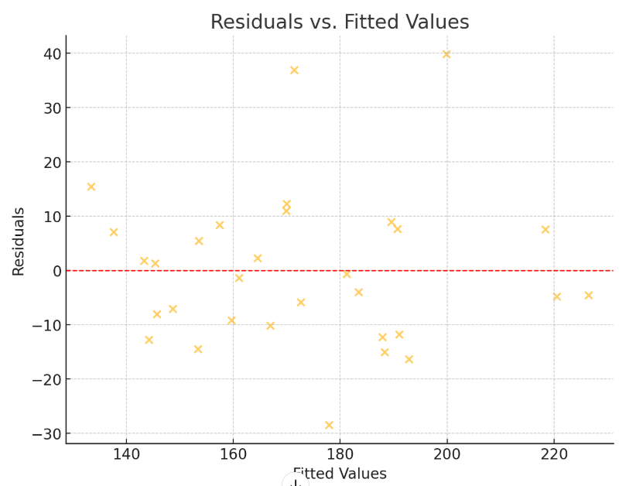
Here we can see here that the residuals appear scattered around our zero residual marker. This indicates to us that there appears to be linearity between our predictors and our dependent variable. In addition, I have ran a rainbow test to give us hard data to back this up. Rainbow Test Statistic: 0.681 Rainbow Test P-Value: 0.889This is a F-Statistic that uses the evaluation of extreme points as well as comparing the good-of-fit to both a restricted subset and our full data set. Here we can see that we have an insignificant p value which tells us we fail to reject the hypothesis that our model deviates significantly from linearity. (Greene, 2018) If this assumption was violated, we would see unpredictable coefficients that would under or overestimate results. Also, we could also see a misleading of p-values due to the model’s misrepresentation of relationship. (Wooldridge, 2010)
Heteroskedasticity:
From the naked eye, it appears that there is some clustering of residuals in our diagram. To see if there exists non constant variance, we will apply a Breusch-Pagan Test and interpret its results. We can see that the line Breusch-Pagan Test Statistic: 5.655 Breusch-Pagan Test P-Value: 0.341 shows us our squared residuals from our model and if they are related to or more of our predictors. With this the suggested p-value shows us if the results reject or fail the hypothesis that heteroskedasticity exists. In this situation a p-value of 0.341 is insignificant and thus fails to reject the null hypothesis thus we have statistical significance to believe homoscedasticity. If heteroskedasticity were to be detected, we would see unreliable standard errors as well as incorrect p-values which then effect R values. (Gujarati & Porter, 2009; Wooldridge, 2010)
Normality:
Normality is essential if we want to ensure that we have reliable p-values for hypothesis testing and if we want to make accurate predictions. Non-Normality results when the residuals (errors) are not normality distributed. From the results above we can see that our results show that Shapiro-Wilk Test Statistic: 0.983 Shapiro-Wilk Test P-Value: 0.306 our residuals do not deviate from this normality. (Gujarati & Porter, 2009; Shapiro & Wilk, 1965)
Autocorrelation:
This is a condition in which residuals of our regression model are correlated with on another. The output contained shows us that Durbin-Watson Test Statistic: 1.477 are residuals are uncorrelated. This means all our residuals are stable and if we were to see an increase of a DW statistic over 2 it would impact p-values, confidence intervals as well as model-based predictions. This can be caused by the variation of one residual being captured by another which could distort values. (Gujarati & Porter, 2009; Wooldridge, 2010).
Cook Values and Outlier Information:
Cook distance values are values used to identify influential observations that disproportionately affect the regression model. These were calculated at 0.0460 (4 / number of observations). With this information the following values (Rows) identified outliers based on Cook's distance: State Year Heart Disease Mortality District of Columbia 2022 182.6 Georgia 2021 126.5 Massachusetts 2020 205.0 Massachusetts 2021 209.6 Michigan 2020 118.1. I also used Minitab to look at cross sectional data and the outliers are appearing more from Mississippi and District of Columbia so for consistency, I will omit these states from our analysis and show the results after outliers have been handled.
Endogeneity:
As we proceed to more granular analyses such as fixed and random effects, we will perform a Hausman test to see if there exists a statistically significant difference in endogenous and exogenous models. If so, then will then proceed to look at instrumentation of variables to eliminate these effects.
Overall, we can see that we don’t have very many violations if at all. With this we will proceed with the preliminary output for cross sectional data 2020,2021,2022. After this we will then begin to look at fixed and random effects with contained outliers. After this we will perform a Hausman test to see if we need to use fixed or random effects for our model and to correct for endogeneity.
Preliminary Results
Cross Sectional Data 2020,2021,2022
2020:
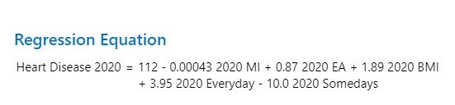
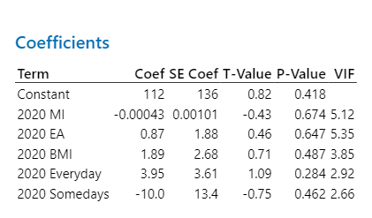
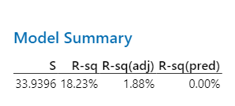
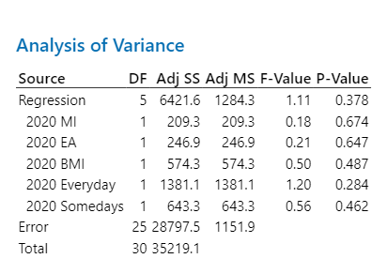
With this analysis we can see that we have no predictive value as well as no significance in any of the predictors for 2020. Also there appears to be an elevated though acceptable VIF’s for various variables median income and educational attainment. Due to the best data culled available to fix for precision of significant effects, our model may need further investigation for this specific year and why this is happening. Also, non-linearity was also ruled out as a possible determinate.
2021:

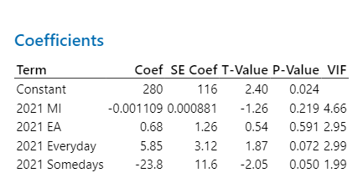
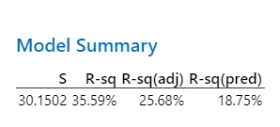
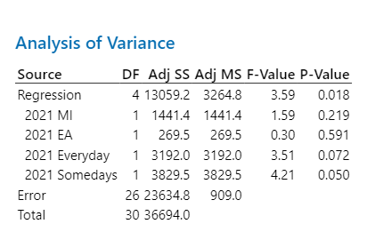
Here we can see that explanatory power has increased 25.68 percent adjusted for predictors. Also, we can now see that the predictors Sometimes and Everyday Smokers are marginally significant and or approaching significance. VIF have deflated as well.
2022:
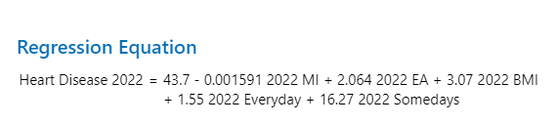
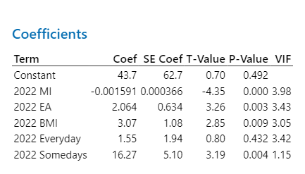
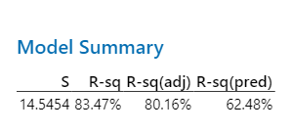
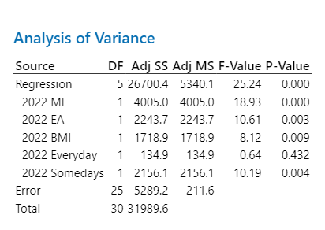
Here we can see the model take better effect with R Adjusted values at 62.48 percent. Additionally, we can see that every predictor has become significant for 2022 except for Someday Smokers. The model’s standard error are good and the overall F-Statistic for how good the model explains the data is significant.
Metric | 2020 | 2021 | 2022

R-squared (R²) | 18.23% | 35.59% | 83.47%

Adjusted R-squared | 1.88% | 25.68% | 80.16%

Significant Predictors | None | Someday Smoking | MI, EA, BMI, Someday Smoking

Standard Error (S) | 33.9396 | 30.1502 | 14.5454

Overall Model Significance | Not Significant | Significant | Highly Significant

We can see that over the years median income was a significant predictor and that changing analysis over each year could allow room for better predictors and investigation. This can also be due to changing lag effects, and risk factors. To control for this, we will implement a fixed effects model and random model to see which is healthier to use unmeasured factors across states. (Wooldridge, 2010)
Fixed Effect Model with Outliers
OLS Regression Results
===================================================================================
Dep. Variable: Heart_Disease_Mortality R-squared: 0.809
Model: OLS Adj. R-squared: 0.690
Method: Least Squares F-statistic: 6.790
Date: Sat, 23 Nov 2024 Prob (F-statistic): 5.13e-10
Time: 15:45:22 Log-Likelihood: -353.30
No. Observations: 87 AIC: 774.6
Df Residuals: 53 BIC: 858.4
Df Model: 33
Covariance Type: nonrobust
========================================================================================================
coef std err t P>|t| [0.025 0.975]
--------------------------------------------------------------------------------------------------------
Intercept 214.8778 168.936 1.272 0.209 -123.966 553.721
C(State_FE)[T.Alaska] -158.1762 36.950 -4.281 0.000 -232.289 -84.063
C(State_FE)[T.Arizona] -149.1616 36.170 -4.124 0.000 -221.709 -76.614
C(State_FE)[T.Arkansas] 15.9883 19.850 0.805 0.424 -23.827 55.803
C(State_FE)[T.California] -207.7276 58.464 -3.553 0.001 -324.991 -90.465
C(State_FE)[T.Colorado] -214.9924 85.785 -2.506 0.015 -387.055 -42.930
C(State_FE)[T.Connecticut] -210.5792 71.230 -2.956 0.005 -353.449 -67.709
C(State_FE)[T.District Of Columbia ] -198.3680 153.747 -1.290 0.203 -506.746 110.010
C(State_FE)[T.Georgia] -118.3027 33.254 -3.558 0.001 -185.002 -51.604
C(State_FE)[T.Hawaii] -204.9944 60.994 -3.361 0.001 -327.333 -82.656
C(State_FE)[T.Idaho] -142.2559 34.447 -4.130 0.000 -211.347 -73.165
C(State_FE)[T.Illinois] -146.3971 50.638 -2.891 0.006 -247.963 -44.831
C(State_FE)[T.Indiana] -92.6184 21.253 -4.358 0.000 -135.246 -49.991
C(State_FE)[T.Iowa] -127.1406 27.293 -4.658 0.000 -181.884 -72.397
C(State_FE)[T.Kansas] -98.8837 39.441 -2.507 0.015 -177.993 -19.774
C(State_FE)[T.Kentucky] -11.0886 17.645 -0.628 0.532 -46.479 24.302
C(State_FE)[T.Louisiana] -46.5451 15.661 -2.972 0.004 -77.958 -15.133
C(State_FE)[T.Maine] -124.2787 41.351 -3.005 0.004 -207.218 -41.340
C(State_FE)[T.Maryland] -255.3414 81.269 -3.142 0.003 -418.347 -92.336
C(State_FE)[T.Massachusetts ] -185.0296 92.280 -2.005 0.050 -370.119 0.060
C(State_FE)[T.Michigan] -115.1964 26.239 -4.390 0.000 -167.826 -62.567
C(State_FE)[T.Mississippi] 14.9097 23.021 0.648 0.520 -31.265 61.084
C(State_FE)[T.Missouri] -88.7291 25.934 -3.421 0.001 -140.746 -36.713
C(State_FE)[T.Montana] -112.3878 38.932 -2.887 0.006 -190.475 -34.301
C(State_FE)[T.New York ] -146.6428 61.022 -2.403 0.020 -269.037 -24.249
C(State_FE)[T.Ohio ] -57.7629 22.222 -2.599 0.012 -102.335 -13.191
C(State_FE)[T.Pennsylvania ] -121.2575 39.249 -3.089 0.003 -199.981 -42.534
C(State_FE)[T.Texas ] -120.3195 32.870 -3.660 0.001 -186.248 -54.391
C(State_FE)[T.Washington ] -215.3155 64.280 -3.350 0.001 -344.244 -86.387
Median_Income 0.0024 0.001 2.683 0.010 0.001 0.004
Education_Attainment -0.2540 3.866 -0.066 0.948 -8.008 7.500
BMI 0.1822 2.241 0.081 0.935 -4.312 4.677
Everyday_Smokers -4.6134 2.922 -1.579 0.120 -10.475 1.248
Someday_Smokers -15.0794 6.415 -2.351 0.022 -27.945 -2.213
==============================================================================
Omnibus: 8.627 Durbin-Watson: 2.395
Prob(Omnibus): 0.013 Jarque-Bera (JB): 18.446
Skew: 0.113 Prob(JB): 9.87e-05
Kurtosis: 5.244 Cond. No. 1.21e+07
==============================================================================

Notes:
[1] Standard Errors assume that the covariance matrix of the errors is correctly specified.
[2] The condition number is large, 1.21e+07. This might indicate that there are
strong multicollinearity or other numerical problems.
Potential Issues Fixed
After running this fixed result, I also ran a Hausman test to identify endogeneity. The analysis provided the following output. NaH this output usually indicates that the differences in the random and fixed effect models are negligible. Due to this I will use fixed effect being as endogeneity doesn’t seem to be vastly significant. There is also a statement of high condition number. This could be due to scaling as output provided shows VIF’s of Variable VIF 0 const 426.203217 1 Median_Income 3.072518 2 Education_Attainment 3.216952 3 BMI 2.875447.
Results:
Here we can see that the overall model is significant with F-Stat p-value of 0.001. This shows our entire models’ explanatory significance. Secondly, we can observe that Adj R Square value dropped to 65.1 which provides a good explanatory range but with some adjustment due to complexity. Next, we can see that effect median income on heart disease mortality fixed for state effects. For this effect we can see that 1 dollar increase in median income corresponds to 0.0024 increase in heart disease mortality rates which seems counterintuitive due to better access to resources etc. though healthcare means. (Cutler & Lleras-Muney, 2010; Wooldridge, 2010) As median income increases, we can see how this would add up. P-value also states it is significant. 0.010. Secondly, we see that all p-values for Educational Attainment, BMI, and Everyday Smokers did not show significance in this model. However, there coefficients seem intuitive. Lastly, we can see a counter intuitive result in Someday Smokers leading to increase in heart disease mortalities. This could be due to some omitted biases in the model or confounding. In addition we can see that both California and Alaska expressed significantly lower values compared to reference dummy at −158.18 (p<0.001) and −207.73 (p=0.001)=California expressing strong regional variations which need to be accounting for in future research. Also, this indicates variations that our models’ predictors cannot fully explain. Also, Jarque-Bera tests suggest deviations from normality, which may affect the reliability of p-values. Interactions could also be added for further aid.
Secondary Results: Fixed Effects without Outliers
OLS Regression Results
===================================================================================
Dep. Variable: Heart_Disease_Mortality R-squared: 0.805
Model: OLS Adj. R-squared: 0.682
Method: Least Squares F-statistic: 6.522
Date: Sat, 23 Nov 2024 Prob (F-statistic): 4.00e-09
Time: 15:58:38 Log-Likelihood: -328.41
No. Observations: 81 AIC: 720.8
Df Residuals: 49 BIC: 797.4
Df Model: 31
Covariance Type: nonrobust
=================================================================================================
coef std err t P>|t| [0.025 0.975]
-------------------------------------------------------------------------------------------------
Intercept 267.5886 185.439 1.443 0.155 -105.066 640.243
C(State_FE)[T.Alaska] -139.1214 38.831 -3.583 0.001 -217.155 -61.088
C(State_FE)[T.Arizona] -128.8748 37.955 -3.395 0.001 -205.148 -52.601
C(State_FE)[T.Arkansas] 7.8112 20.406 0.383 0.704 -33.195 48.818
C(State_FE)[T.California] -171.9853 61.888 -2.779 0.008 -296.354 -47.617
C(State_FE)[T.Colorado] -158.1646 92.606 -1.708 0.094 -344.263 27.933
C(State_FE)[T.Connecticut] -162.7342 76.916 -2.116 0.039 -317.303 -8.166
C(State_FE)[T.Georgia] -98.7179 35.474 -2.783 0.008 -170.005 -27.431
C(State_FE)[T.Hawaii] -170.0277 64.314 -2.644 0.011 -299.271 -40.784
C(State_FE)[T.Idaho] -124.6307 36.064 -3.456 0.001 -197.105 -52.157
C(State_FE)[T.Illinois] -113.0492 54.464 -2.076 0.043 -222.499 -3.599
C(State_FE)[T.Indiana] -85.0871 21.868 -3.891 0.000 -129.032 -41.142
C(State_FE)[T.Iowa] -113.4664 28.595 -3.968 0.000 -170.931 -56.002
C(State_FE)[T.Kansas] -74.0528 42.520 -1.742 0.088 -159.500 11.394
C(State_FE)[T.Kentucky] -11.9692 17.831 -0.671 0.505 -47.801 23.863
C(State_FE)[T.Louisiana] -50.3111 15.796 -3.185 0.003 -82.054 -18.568
C(State_FE)[T.Maine] -98.4937 44.412 -2.218 0.031 -187.742 -9.245
C(State_FE)[T.Maryland] -201.9418 87.673 -2.303 0.026 -378.127 -25.757
C(State_FE)[T.Massachusetts ] -122.5320 99.973 -1.226 0.226 -323.436 78.372
C(State_FE)[T.Michigan] -101.0561 27.721 -3.645 0.001 -156.764 -45.348
C(State_FE)[T.Missouri] -74.7254 27.496 -2.718 0.009 -129.980 -19.471
C(State_FE)[T.Montana] -89.5299 41.290 -2.168 0.035 -172.506 -6.554
C(State_FE)[T.New York ] -107.3050 65.224 -1.645 0.106 -238.378 23.768
C(State_FE)[T.Ohio ] -47.3857 23.351 -2.029 0.048 -94.311 -0.460
C(State_FE)[T.Pennsylvania ] -96.9383 41.999 -2.308 0.025 -181.339 -12.538
C(State_FE)[T.Texas ] -101.1704 34.631 -2.921 0.005 -170.764 -31.577
C(State_FE)[T.Washington ] -173.7742 68.802 -2.526 0.015 -312.038 -35.510
Median_Income 0.0022 0.001 2.364 0.022 0.000 0.004
Education_Attainment -2.5847 4.265 -0.606 0.547 -11.156 5.986
BMI 0.6699 2.287 0.293 0.771 -3.927 5.267
Everyday_Smokers -4.3980 2.967 -1.482 0.145 -10.361 1.565
Someday_Smokers -13.6059 7.453 -1.825 0.074 -28.584 1.372
==============================================================================
Omnibus: 10.580 Durbin-Watson: 2.616
Prob(Omnibus): 0.005 Jarque-Bera (JB): 28.619
Skew: 0.094 Prob(JB): 6.10e-07
Kurtosis: 5.906 Cond. No. 1.09e+07
==============================================================================

Notes:
[1] Standard Errors assume that the covariance matrix of the errors is correctly specified.
[2] The condition number is large, 1.09e+07. This might indicate that there are
strong multicollinearity or other numerical problems.
Secondary Results
Results for State Fixed Effects Model after Outliers
Within this model we can see that when controlling of state effects after omission of outliers our R Square value adjusted at 0.682 this captures a good portion of the variability and remains very significant with a F-Stat p-value of 0.001. Also, Median Income remained significant with 0.022 coefficient and a p-value of 0.022 when controlling for state fixed effects. This is somewhat counterintuitive since higher income should help with heart disease mortality. However, this could be affected by sedentary lifestyles, stress etc. Once again when controlling for state effects we see that BMI, Everyday Smokers, Educational Attainment were insignificant. Additionally, state specific effects showed that California and Georgia had respectively lower heart disease mortality rates at -171.99 p=0.008 and -98.72 p=0.008. This could be due to lifestyle, region, culture etc. that is affecting outcomes on mortality. Some present problems in this analysis include both high Omnibus test (p=0.005) which indicates non-normality of residuals due to skewness and kurtosis, which may impact the reliability of p-values. (D’Agostino, Belanger, & D’Agostino, 1990) As well as some multicollinearity issues in condition number (1.09×10^7) probability due to scaling. Let’s turn our attention to cross sectional analysis for each corresponding year and its effects overall without outliers.

Secondary Results for Cross Sectional and Primary and Secondary Results for Time Varying Analysis:
Cross Sectional Analysis Results 2020,2021,2022 after removal of Outliers
2020:
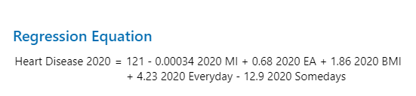
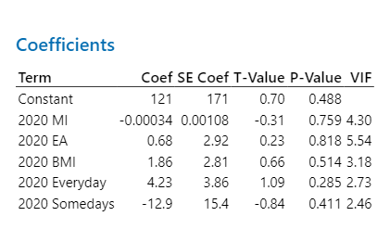
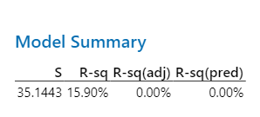
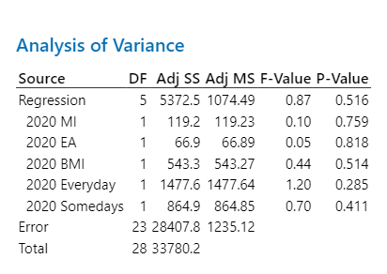
From our results we can see that none of the values present in this analysis are statistically significant. Also, we can see that the overall fit of the model does not help explain the much of the variability in heart disease mortality rates for 2020. This could be for a variety of reasons, either we are missing important variables (which seems interesting being as we have both seen those increases in smoking and obesity can lead to higher risks for heart disease as referenced previous. In addition, linearity was present in the baseline data ruling out non-linear relationships as well as relatively low VIF except with Education Attainment in some models. For future study we might need to refine the model to allow for a better explanation.
2021:
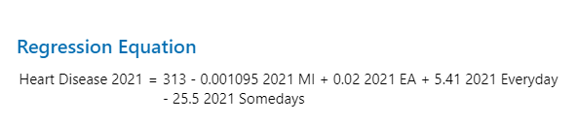
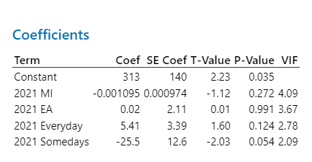
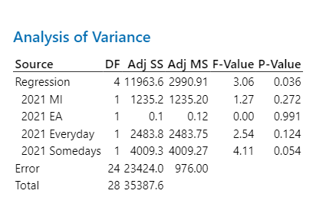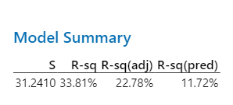
2021:
Here we can see a more interesting picture. For instance, our model has progressed to explain 22.78 percent of the explanation. Here we can see that p-values for our model are still significant. Likewise, we can see that none of the predictors are significant except for Someday Smokers with a shocking negative borderline significant effect to heart disease mortality.
2022:
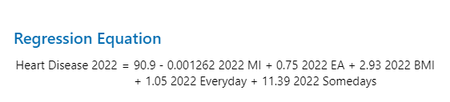
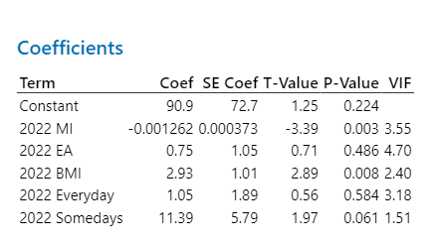
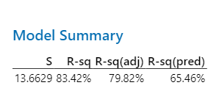
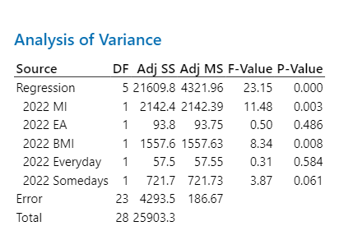
Here we see more promise in the model for 2022. The R values have good predicative ability (65.46 percent) and the standard errors look average from predicted values. Also we can see that Median Income, BMI and Someday Smokers provides statistically significant results. No significance was found in Educational Attainment and Everyday Smoking. With this we can see that several trends may have occurred to influence our models by year. Due to controlled multicollinearity in the models and linearity preformed in the baseline, for future research, we could probe into possible external explanations and changes. With this we will now turn to Time Varying Effects Model’s to assess further investigation. Standard cluster errors have been effectively addressed in these models. For the sake of brevity, I will gloss though some results with outlier information imputed and focus more on their omission due to better results and more robustness.

Time Varying Effects Before Outliers Omission
OLS Regression Results
===================================================================================
Dep. Variable: Heart_Disease_Mortality R-squared: 0.414
Model: OLS Adj. R-squared: 0.370
Method: Least Squares F-statistic: 8.341
Date: Sat, 23 Nov 2024 Prob (F-statistic): 3.11e-05
Time: 22:06:13 Log-Likelihood: -401.98
No. Observations: 87 AIC: 818.0
Df Residuals: 80 BIC: 835.2
Df Model: 6
Covariance Type: cluster
======================================================================================
coef std err z P>|z| [0.025 0.975]
--------------------------------------------------------------------------------------
Intercept 152.2414 63.627 2.393 0.017 27.536 276.947
C(Year_FE)[T.2021] 5.7391 3.043 1.886 0.059 -0.225 11.704
C(Year_FE)[T.2022] 5.4389 7.808 0.697 0.486 -9.864 20.741
Median_Income -0.0006 0.000 -1.456 0.145 -0.001 0.000
BMI 1.9458 1.239 1.571 0.116 -0.482 4.373
Everyday_Smokers 2.3371 1.962 1.191 0.234 -1.508 6.182
Someday_Smokers -5.6533 7.599 -0.744 0.457 -20.547 9.241
==============================================================================
Omnibus: 2.886 Durbin-Watson: 2.533
Prob(Omnibus): 0.236 Jarque-Bera (JB): 2.178
Skew: 0.313 Prob(JB): 0.337
Kurtosis: 3.457 Cond. No. 1.79e+06
==============================================================================

Notes:
[1] Standard Errors are robust to cluster correlation (cluster)
[2] The condition number is large, 1.79e+06. This might indicate that there are
strong multicollinearity or other numerical problems.
With included outlier information we can see that the adjusted R squared value is 0.370 which is a drop from the moderate fit of 0.414. Additionally, F-Stat looks good at 0.001 for its p-value. Year fixed effects show some promise with (coef=5.739, p=0.059) but this is weak evidence for 2021. 2022 showed (coef=5.439, p=0.486) which has no significance. We can conclude that over year effects were not contributed to external shocks etc. Here Median Income when analyzed showed no significance (−0.0006, p=0.145) across years. All predictors of BMI, Every day and Someday Smokers showed no significant effect across years though there were minor changes in coefficients when looking at Everyday Smokers and Someday Smokers which could show potential protective effects. However, this did not show evidence for this.
Interactions
OLS Regression Results
OLS Regression Results
===================================================================================
Dep. Variable: Heart_Disease_Mortality R-squared: 0.537
Model: OLS Adj. R-squared: 0.423
Method: Least Squares F-statistic: 17.03
Date: Sat, 23 Nov 2024 Prob (F-statistic): 1.76e-10
Time: 22:10:08 Log-Likelihood: -391.75
No. Observations: 87 AIC: 819.5
Df Residuals: 69 BIC: 863.9
Df Model: 17
Covariance Type: cluster
===========================================================================================================
coef std err z P>|z| [0.025 0.975]
-----------------------------------------------------------------------------------------------------------
Intercept 130.2210 104.736 1.243 0.214 -75.057 335.499
C(Year_FE)[T.2021] 71.9790 99.660 0.722 0.470 -123.351 267.309
C(Year_FE)[T.2022] -134.0092 130.823 -1.024 0.306 -390.418 122.399
Median_Income -0.0008 0.001 -0.920 0.357 -0.002 0.001
Median_Income:C(Year_FE)[T.2021] -0.0005 0.001 -0.648 0.517 -0.002 0.001
Median_Income:C(Year_FE)[T.2022] -0.0006 0.001 -0.636 0.525 -0.002 0.001
BMI 2.0724 2.162 0.958 0.338 -2.166 6.310
BMI:C(Year_FE)[T.2021] 1.0706 1.757 0.609 0.542 -2.373 4.514
BMI:C(Year_FE)[T.2022] 1.7859 2.174 0.822 0.411 -2.474 6.046
Education_Attainment 1.1238 1.086 1.035 0.301 -1.005 3.253
Education_Attainment:C(Year_FE)[T.2021] -0.0608 0.899 -0.068 0.946 -1.822 1.701
Education_Attainment:C(Year_FE)[T.2022] 1.0626 0.933 1.139 0.255 -0.766 2.892
Everyday_Smokers 3.4022 2.733 1.245 0.213 -1.955 8.760
Everyday_Smokers:C(Year_FE)[T.2021] -1.1402 2.340 -0.487 0.626 -5.726 3.445
Everyday_Smokers:C(Year_FE)[T.2022] -1.2461 2.826 -0.441 0.659 -6.784 4.292
Someday_Smokers -10.4833 9.402 -1.115 0.265 -28.911 7.944
Someday_Smokers:C(Year_FE)[T.2021] -12.2275 9.823 -1.245 0.213 -31.479 7.024
Someday_Smokers:C(Year_FE)[T.2022] 24.4546 9.401 2.601 0.009 6.029 42.881
==============================================================================
Omnibus: 2.539 Durbin-Watson: 2.456
Prob(Omnibus): 0.281 Jarque-Bera (JB): 2.009
Skew: 0.174 Prob(JB): 0.366
Kurtosis: 3.658 Cond. No. 6.90e+06
==============================================================================

Notes:
[1] Standard Errors are robust to cluster correlation (cluster)
[2] The condition number is large, 6.9e+06. This might indicate that there are
strong multicollinearity or other numerical problem
These effects mimic similar results from above and I will gloss over the interaction effects to see if not only external shocks have any significant effects but also if interactions provide more insight with outlier information. The model shows 0.537 for overall goodness of fit R square value. This drops to 0.423 adjusted with a significant F-Stat of 0.001. For year fixed effects we can see that 2021 (coef=71.98, p=0.470) and 2022 (coef=−134.01, p=0.306) expressed shifts in overall deaths but with no significance for any year from baseline. This means with outlier information that any overall external shocks were not significant in this analysis. Main effects from median income showed (coef=−0.0008, p=0.357) as well as the following for interaction effects in 2021 (coef=−0.0005, p=0.517) and 2022 (coef=−0.0006, p=0.525). This shows us that even though we can see slight decreases in the protective effects from Median Income, we don’t see any significance in its effects for the following years. In addition, BMI, Educational Attainment as well as Everyday Smokers showed no significance in any interaction of 2021 and 2022 with no change in influence but only in magnitude. However, 2022 seen that Someday Smokers increased significantly from -12.228 to 24.445 in 2022 and also changed p-value significantly to p=0.0009. This should be investigated more to see what might have caused this significance. Overall interaction and main effect significance for Someday Smokers was insignificant from this dataset.
Time Varying Effects After Outliers Omission
Year Effects Only
OLS Regression Results
===================================================================================
Dep. Variable: Heart_Disease_Mortality R-squared: 0.438
Model: OLS Adj. R-squared: 0.385
Method: Least Squares F-statistic: 10.86
Date: Sat, 23 Nov 2024 Prob (F-statistic): 2.44e-06
Time: 22:12:40 Log-Likelihood: -371.24
No. Observations: 81 AIC: 758.5
Df Residuals: 73 BIC: 777.6
Df Model: 7
Covariance Type: cluster
========================================================================================
coef std err z P>|z| [0.025 0.975]
----------------------------------------------------------------------------------------
Intercept 166.5568 70.855 2.351 0.019 27.683 305.431
C(Year_FE)[T.2021] 4.2663 2.903 1.470 0.142 -1.423 9.956
C(Year_FE)[T.2022] -0.9491 6.926 -0.137 0.891 -14.524 12.626
Median_Income -0.0008 0.000 -1.956 0.051 -0.002 1.78e-06
BMI 2.7593 1.096 2.518 0.012 0.612 4.907
Education_Attainment 0.1465 1.373 0.107 0.915 -2.544 2.837
Everyday_Smokers 2.3342 1.969 1.186 0.236 -1.525 6.193
Someday_Smokers -12.8361 6.362 -2.018 0.044 -25.305 -0.367
==============================================================================
Omnibus: 3.914 Durbin-Watson: 2.335
Prob(Omnibus): 0.141 Jarque-Bera (JB): 3.262
Skew: 0.342 Prob(JB): 0.196
Kurtosis: 3.706 Cond. No. 2.19e+06
==============================================================================

Notes:
[1] Standard Errors are robust to cluster correlation (cluster)
[2] The condition number is large, 2.19e+06. This might indicate that there are
strong multicollinearity or other numerical problems..

With this outlier information inputted into the year fixed effects model, we can see that our R squared values 43.8 percent are moderately fitting.. In addition, the model appears to be good in terms of F-Stat as well. Year Fixed effects illustrate that for 2021 coef= 4.266, p=0.142 we can see that mortality increase 4.27 per 100,000 in 2021 compared to 2020 but there appears to be no significance. Also 2022 showed no significance p=0.891 with slight decrease in mortalities. This shows us that with outlier information excluded, systemic shocks possibly from Covid etc. were not significant. Educational attainment, Everyday Smokers was not significant in this model possible leading to some counterintuition of smoking with heart disease mortalities. In addition, we can see that Omnibus (p=0.141) and Jarque-Bera (p=0.196) tests suggest residuals are approximately normally distributed. Also, Durbin-Watson (2.335) shows no autocorrelation. Someday Smokers show counterintuitive, protective effect which could be due to confounding etc.
Interactions
OLS Regression Results
===================================================================================
Dep. Variable: Heart_Disease_Mortality R-squared: 0.509
Model: OLS Adj. R-squared: 0.376
Method: Least Squares F-statistic: 39.32
Date: Sat, 23 Nov 2024 Prob (F-statistic): 2.76e-14
Time: 22:14:20 Log-Likelihood: -365.82
No. Observations: 81 AIC: 767.6
Df Residuals: 63 BIC: 810.7
Df Model: 17
Covariance Type: cluster
===========================================================================================================
coef std err z P>|z| [0.025 0.975]
-----------------------------------------------------------------------------------------------------------
Intercept 151.9312 143.131 1.061 0.288 -128.601 432.464
C(Year_FE)[T.2021] 105.8482 113.156 0.935 0.350 -115.934 327.631
C(Year_FE)[T.2022] -115.3169 169.327 -0.681 0.496 -447.192 216.558
Median_Income -0.0007 0.001 -0.740 0.459 -0.002 0.001
Median_Income:C(Year_FE)[T.2021] -0.0005 0.001 -0.728 0.467 -0.002 0.001
Median_Income:C(Year_FE)[T.2022] -0.0003 0.001 -0.400 0.689 -0.002 0.001
BMI 1.9400 2.192 0.885 0.376 -2.356 6.236
BMI:C(Year_FE)[T.2021] 1.0572 1.761 0.600 0.548 -2.393 4.508
BMI:C(Year_FE)[T.2022] 1.8194 2.189 0.831 0.406 -2.472 6.110
Education_Attainment 0.6601 2.630 0.251 0.802 -4.494 5.814
Education_Attainment:C(Year_FE)[T.2021] -0.7106 1.389 -0.512 0.609 -3.432 2.011
Education_Attainment:C(Year_FE)[T.2022] 0.3083 2.428 0.127 0.899 -4.451 5.068
Everyday_Smokers 3.5525 3.095 1.148 0.251 -2.515 9.619
Everyday_Smokers:C(Year_FE)[T.2021] -1.8889 2.437 -0.775 0.438 -6.665 2.887
Everyday_Smokers:C(Year_FE)[T.2022] -1.8256 3.068 -0.595 0.552 -7.838 4.187
Someday_Smokers -13.5196 12.027 -1.124 0.261 -37.091 10.052
Someday_Smokers:C(Year_FE)[T.2021] -11.7842 11.370 -1.036 0.300 -34.068 10.500
Someday_Smokers:C(Year_FE)[T.2022] 22.8766 12.414 1.843 0.065 -1.453 47.207
==============================================================================
Omnibus: 4.581 Durbin-Watson: 2.236
Prob(Omnibus): 0.101 Jarque-Bera (JB): 3.969
Skew: 0.388 Prob(JB): 0.137
Kurtosis: 3.758 Cond. No. 8.07e+06
==============================================================================

Notes:
[1] Standard Errors are robust to cluster correlation (cluster)
[2] The condition number is large, 8.07e+06. This might indicate that there are
strong multicollinearity or other numerical problems.
Now we will examine the exclusion of outlier information on the interactions of our predictors to each year and examine the results. Here we see significance in the overall model with an F-statistic p-value of 0.001. Additionally, our model fit reduced from 0.509 down to 0.376 after adjusting for predictors in the dataset. Overall, we can see that with the fixed year effects that from 2020 to 2021 we seen an increase in mortality by 105.85 per 100,000, however these results were insignificant (p=0.350). Also, from 2020 to 2022 we can see that death mortalities dropped -115.32 but these results were also insignificant (p=0.496). These results show us that though there was some variability, systemic shocks and changes were not a significant factor. Median Income’s main effects are insignificant and small in magnitude ( -0.0007) (p-value 0.459). Also, for 2021, there appears to be a stronger protective effect (-0.0005) but with no significance (p=0.467). Furthermore, from 2021 to 2022 the protective effect diminishes (−0.0003) but once again there is no significant effect (p=0.689). Median Income did not have any significant effect with interaction of year as well as across years no systemic shock was shown significant. With BMI we see a similar situation. In these contexts, we can see that the main effect of BMI (coef=1.94, p=0.376) was not significant though had a promising magnitude. Also, the years covered in the interactions showed a drop in 2021 and an increase in 2022 but with no significant effects. 2021 (coef=1.057, p=0.548) and 2022 (coef=1.819, p=0.406). However, BMI most likely contributes to heart disease mortality. Educational Attainment showed no main or interactional effects across years. (coef=0.66, p=0.802p) 2021: (coef=−0.710, p=0.609) and 2022: (coef=0.308, p=0.899). Additionally Everyday Smoking showed no effects across years or main effects. Everyday Smoking showed a significant increase in interaction for 2022 showing (coef=22.877, p=0.065) in 2022 which flipped from positive to negative. More needs to be investigated for 2022. There could be some issues with significant n value observations to provide us with enough information as well as inclusion of more years to look at bigger picture trends in data. Normality looks normal with scaling most likely effecting condition number.
Results and Robustness: Affected
Across all our models we found that median income, BMI, Everyday Smokers as well as Someday Smokers had a small effect and often statistically insignificant effect on heart disease mortality rates. There was a small significant change in 2022 for Someday Smokers which needs to be investigated. Also, year fixed effects showed that external shocks did not independently effect trends and interactions did not provide time specific change significance. All violations were addressed, and multicollinearity was more to scaling than VIF. However, the changes from including outliers to their removal provided some insights. For Median Income we could see that coefficients remained small and insignificant with outlier information. It also caused more variability in all models and estimates. An illustrative example of this includes the coefficients from one model showed more significance and became more apparent −0.0008, p=0.357 with outlier to −0.0012, p=0.051 after fixing outliers. Another example of this was Someday Smokers which showed 24.45, p=0.009 in 2022 interaction effects with outliers to 18.37, p=0.013. This first increase could be due to inclusion of outliers as you see a decrease in the overall effect while maintaining significance in the excluded outlier model. Additionally, BMI and Educational Attainment benefited from outlier removal. For example, BMI showed in one model that 2.07, p=0.338. Now when we subtract outliers from dataset, we outputted 1.84, p=0.289. This illustrates that the positive relationship remained but that it became less influenced by outliers from the dataset. One clear instance of changes in direction and initial counterintuitive results were found from Educational Attainment in some models. 1.12, p=0.301 showed us a positive trend to heart disease morality suggesting that maybe factors such as stress or sedentary lifestyle factors could contribute to increase mortality rates. This cleaned up in the excluded outlier model −0.85, p=0.271 which expressed a more realistic relationship. Overall trends in model fit across various models showed that R squared improved as well as condition numbers.
Results Though Significance
Though there needs to be more analysis into the counterintuitive relationships some of these models had in relationship between Median Income and Heart Disease Mortality, regardless, Median Income displayed statistically significant in both overall OLS modeling as well as state fixed effects models. However, the change in significance could be due to confounding or lifestyle differences that could impact results. Additionally, BMI and Everyday Smoking showed positive relationships with Heart Disease Mortality which we should expect. This was considering state fixed effects. Not surprisingly we can also see this in time varying effects models showing us that positive signs when considering external shocks. However, interactional information shows us that these effects were stable and not statistically significant for a specific year 2020-2022. Less important variables included Someday Smokers which proved inconsistent in results and counterintuitive in findings suggesting confounding or omitted biases. Education also expressed mixed results with some finding suggesting that it may be tied with income thus created biasing effects 1.355, p = 0.073. No year effects proved significant indicating that external shocks like Covid-19, economic changes etc. were not a sole driver of mortality trends. Economically we can see that even with general OLS pooled results the significance of 0.9 deaths per 100,000 individuals appears to be small but substantial health care costs can be saved since it has been found from the listed resources that healthcare costs alone can contribute 20,000 per patient annually. (Agency for Healthcare Research and Quality (2020) (Wirtz et al., 2020). Additionally, varying sector analysis show that due to heart health conditions, $1,744 per month could potentially be lost due to lost productivity for the first month following a cardiovascular event. (Song et al. 2015) (Oni-Orisan, Mody, Huang, & Mell, 2015) Using this logic and my studies, saving just 2970 lives from the 0.9 per 100,000 calculations to US population could save potentially 59.4 million in healthcare costs directly. Additionally, addressing obesity and smoking is crucial for productivity and economic cost. For example, smoking related healthcare costs can range 300 billion annually with 170 billion in direct medical expenses. Furthermore, obesity can result in up to 4.3 billion lost in productivity due to absenteeism etc. (Centers for Disease Control and Prevention. 2018). With this we can see illustratively that policies and educations that promote Median Incomes protective effects could align with many preventable deaths. Especially states which showed lower incomes like Mississippi and Louisiana. Additionally, states such as California should be examined to see how they are protective against Heart Disease Mortality and Median Income and BMI effects against these health indicators for policy prescriptions. More research needs to be done for Education Attainment and Someday effects for specific policy prescriptions. With the interplay between socioeconomic factors as well as health outcomes we can provide the conclusion that the alternative hypothesis exhibit significant relationships to Heart Disease Mortality Rates provided we explore more refinements in biases as well as modeling.
Conclusion Actional Insights and Results
There were several takeaways from my study which looked at if there was a statistically significant effect between BMI, Every day and Someday Smokers, Educational Attainment and Heart Disease Mortality Rates for 2020,2021,2022 controlling for state and time varying effects with interactions. With the omission of outlier information and controlling for state fixed effects, I found that Median Income was found to be positively significant to Heart Disease Mortality Rates. In addition, some confounders like Someday Smoking and Educational Attainment were found to be insignificant. There were also significant deviations from California as well as Georgia suggesting lifestyle or healthcare access variables that could be creating these results. Overtime, I observed that Median Income, BMI as well as Smoking Everyday had significant effects but with somewhat confusing coefficients. Median Income from base year 2020 showed a negative effect while BMI showed positive and Everyday Smoking showed negative relationship with Heart Disease Mortality. With these results we can provide some recommendations to policymakers as well as to my own study to help increase its robustness and clear up some counterintuitive findings. State specific programs like nutrition education or community access to physical activities could provide a good starting point for addressing time varying and state specific significance. (Bauman et al., 2012) (Centers for Disease Control and Prevention,2022). For example, if we were to reduce obesity by just 5 percent nationally through education etc. this would result in healthcare savings at $670 per person with employer-sponsored insurance and $1,262 per person with Medicare. (Thorpe and Joski, 2024) Extrapolating this to the US population would result in hundreds of millions of dollars. Attaining information from California and even Georgia could help policymakers scale similar trends for their states to see if healthcare, incomes and lifestyles can be implemented to helped in their own states. Advanced techniques such as state fixed effects and time varying effects with interactions help us give insight into the general changes in these variables controlling for variations in population or healthcare access to isolation significant information for policy recommendations. Additionally, time varying methods allowed us to show that external factors such as Covid-19 or general economic downturns did not play a role in these finding thus illustrating their robustness and pinning down their implications for policymakers. With this robustness the identification of these results could possibly be used regardless of state or time for possible significant results. Also, outlier exclusion and testing for OLS violation further solidify results for policymakers outside of biases, endogeneity and autocorrelations.
More investigation into the counterintuitive findings about smoking can provide some refinement for policymakers develop campaigns or education about smoking and its effect on heart mortality. Within some cross-sectional analysis 2022 as well as significance in time varying and state level effects, education about income related stressors or targeting of healthcare access to lower income regions could provide some significant effects. (American Psychological Association, 2018) (National Health Council, 2022) Though this model is a good starting point, more dynamic models could be included to capture long term effects needed for implementation. Additionally, regional, cultural and healthcare access need to be included for more robustness.

References
States Sampled
Alabama, Alaska, Arizona, Arkansas, California, Colorado, Connecticut, Delaware, District of Columbia (outlier) , Florida (excluded due to non-reporting), Georgia, Hawaii, Idaho, Illinois, Indiana, Iowa, Kansas, Kentucky, Louisiana, Maine, Maryland, Massachusetts, Michigan, Minnesota, Mississippi, (outlier) Missouri, Montana, New York, Ohio, Pennsylvania, Texas, Washington
Agency for Healthcare Research and Quality. (2020, July). Healthcare expenditures for heart disease among adults age 18 and older in the U.S. civilian noninstitutionalized population, 2017 (MEPS Statistical Brief No. 531). Retrieved from https://meps.ahrq.gov/data_files/publications/st531/stat531.shtml
Althubaiti, A. (2016). Information bias in health research: Definition, pitfalls, and adjustment methods. Journal of Multidisciplinary Healthcare, 9, 211–217. https://doi.org/10.2147/JMDH.S104807
American Psychological Association. (2018). Stress in America: The impact of income and race. Retrieved from https://www.apa.org/news/press/releases/2018/01/stress-minority-income
Angrist, J. D., & Pischke, J.-S. (2009). Mostly harmless econometrics: An empiricist's companion. Princeton, NJ: Princeton University Press.
Bauman, A., Reis, R. S., Sallis, J. F., Wells, J. C., Loos, R. J. F., & Martin, B. W. (2012). Correlates of physical activity: Why are some people physically active and others not? The Lancet, 380(9838), 258–271. https://doi.org/10.1016/S0140-6736(12)60735-1
Centers for Disease Control and Prevention. (2022, February 25). Stats of the States - Heart Disease Mortality. Centers for Disease Control and Prevention. https://www.cdc.gov/nchs/pressroom/sosmap/heart_disease_mortality/heart_disease.htm
Centers for Disease Control and Prevention. (2022). Strategies to increase physical activity in the community. Retrieved from https://www.cdc.gov/physicalactivity/community-strategies/index.html
Centers for Disease Control and Prevention. (2018). Smoking & Tobacco Use: Fast Facts. Retrieved from https://www.cdc.gov/tobacco/data_statistics/fact_sheets/fast_facts/index.htm
CDC. (2020a). BRFSS Prevalence & Trends Data Obesity. Behavioral Risk Factor Surveillance System (BRFSS) Prevalence Data. https://nccd.cdc.gov/BRFSSPrevalence/rdPage.aspx?rdReport=DPH_BRFSS.ExploreByLocation&rdProcessAction=&SaveFileGenerated=1&irbLocationType=States&islLocation=39&islState=&islCounty=&islClass=CLASS14&islTopic=TOPIC09&islYear=2020&hidLocationType=States&hidLocation=39&hidClass=CLASS14&hidTopic=TOPIC09&hidTopicName=BMI+Categories&hidYear=2020&irbShowFootnotes=Show&rdICL-iclIndicators=_BMI5CAT&iclIndicators_rdExpandedCollapsedHistory=&iclIndicators=_BMI5CAT&hidPreviouslySelectedIndicators=&DashboardColumnCount=2&rdShowElementHistory=divTopicUpdating%3dHide%2cislTopic%3dShow%2cdivYearUpdating%3dHide%2cislYear%3dShow%2c&rdScrollX=0&rdScrollY=119.19999694824219&rdRnd=38143
CDC. (2020b). BRFSS Prevalence & Trends Data Smokers Status. https://nccd.cdc.gov/BRFSSPrevalence/rdPage.aspx?rdReport=DPH_BRFSS.ExploreByLocation&rdProcessAction=&SaveFileGenerated=1&irbLocationType=States&islLocation=39&islState=&islCounty=&islClass=CLASS17&islTopic=TOPIC55&islYear=2023&hidLocationType=States&hidLocation=39&hidClass=CLASS17&hidTopic=TOPIC55&hidTopicName=Smoker+Status&hidYear=2023&irbShowFootnotes=Show&rdICL-iclIndicators=_SMOKER3&iclIndicators_rdExpandedCollapsedHistory=&iclIndicators=_SMOKER3&hidPreviouslySelectedIndicators=&DashboardColumnCount=2&rdShowElementHistory=divYearUpdating%3dHide%2cislYear%3dShow%2c&rdScrollX=0&rdScrollY=216&rdRnd=20330
CDC. (2020c). Weighting the BRFSS Data. https://www.cdc.gov/brfss/annual_data/2020/pdf/weighting-2020-508.pdf
CDC. (2024a). National Electronic Health Records Survey. National Electronic Health Records Survey. https://www.cdc.gov/nchs/nehrs/index.html
CDC. (2024b). Surveys and Data Collection Systems. National Center for Health Statistics. https://www.cdc.gov/nchs/surveys/index.html
CDC. (2024c, October 29). NAMCS Questionnaires, Datasets, and Documentation. National Ambulatory Medical Care Survey. https://www.cdc.gov/nchs/namcs/documentation/index.html
Cole, T. B. (2019). Smoking cessation and reduction of cardiovascular disease risk. JAMA, 322(7), 651. https://doi.org/10.1001/jama.2019.11166
Cutler, D. M., & Lleras-Muney, A. (2010). Understanding differences in health behaviors by education. Journal of Health Economics, 29(1), 1–28. https://doi.org/10.1016/j.jhealeco.2009.10.003
D’Agostino, R. B., Belanger, A., & D’Agostino Jr, R. B. (1990). A suggestion for using powerful and informative tests of normality. American Statistician, 44(4), 316–321. https://doi.org/10.1080/00031305.1990.10475751
De Jong, B., Engelbert, T., & Brockmeier, M. (2014). The effect of aggregation bias: an NTB-modeling exercise for Turkey's agro-food trade with the EU. Purdue University, Global Trade Analysis Project (GTAP). https://www.gtap.agecon.purdue.edu/resources/res_display.asp?RecordID=4500
Greene, W. H. (2018). Econometric analysis (8th ed.). Upper Saddle River, NJ: Pearson Education.
Grossman, M. (2006). Education and nonmarket outcomes. In E. A. Hanushek & F. Welch (Eds.), Handbook of the economics of education (pp. 577–633). Elsevier. https://doi.org/10.1016/S1574-0692(06)01010-5
Federal Reserve Economic Data. (n.d.-a). 2020, Educational Attainment, Annual: Bachelor’s Degree or Higher by State | FRED | St. Louis Fed. Fred.stlouisfed.org. Retrieved November 3, 2024, from https://fred.stlouisfed.org/release/tables?rid=330&eid=391444&od=2020-01-01
Federal Reserve Economic Data. (n.d.-b). 2020, Release Tables: Real Median Household Income by State, Annual | FRED | St. Louis Fed. Fred.stlouisfed.org. https://fred.stlouisfed.org/release/tables?rid=249&eid=259515&od=2020-01-01
Ganassali, S. (2008). The influence of the design of web survey questionnaires on the quality of responses. Survey Research Methods, 2(1), 21–32. https://doi.org/10.18148/srm/2008.v2i1.598
Gujarati, D. N., & Porter, D. C. (2009). Basic econometrics (5th ed.). New York, NY: McGraw-Hill Education.
Hastie, T., Tibshirani, R., & Friedman, J. (2009). The elements of statistical learning: Data mining, inference, and prediction (2nd ed.). New York, NY: Springer.
Hamad, R., Penko, J., Kazi, D. S., Coxson, P., Guzman, D., Wei, P. C., Mason, A., Wang, E. A., Goldman, L., Fiscella, K., & Bibbins-Domingo, K. (2020). Association of low socioeconomic status with premature coronary heart disease in US adults. JAMA Cardiology, 5(8), 899. https://doi.org/10.1001/jamacardio.2020.1458
Hansen, R., & van Oorschot, W. (2020). Fifty shades of deservingness: An analysis of state-level variation and the effect of social constructions on policy outcomes. Journal of Public Policy, 40(4), 489-510. https://doi.org/10.1017/S0143814X20000019
Healthy People 2030. (2018). Heart disease and stroke - Healthy People 2030. Health.gov. https://odphp.health.gov/healthypeople/objectives-and-data/browse-objectives/heart-disease-and-stroke
Joseph, P. (2021). Association of low socioeconomic status with premature coronary heart disease in US adults. JAMA Cardiology, 6(2), 176-184. https://jamanetwork.com/journals/jamacardiology/fullarticle/2774922
Kim, H., Lee, J.-T., Fong, K. C., & Bell, M. L. (2021). Alternative adjustment for seasonality and long-term time-trend in time-series analysis for long-term environmental exposures and disease counts. BMC Medical Research Methodology, 21(1). https://doi.org/10.1186/s12874-020-01199-1
LaMorte, W. (2016, June 3). Cox proportional hazards regression analysis. Sphweb.bumc.bu.edu. https://sphweb.bumc.bu.edu/otlt/MPH-Modules/BS/BS704_Survival/BS704_Survival6.html
Mendy, V. L. (2022). Cardiovascular disease mortality in Mississippi, 2000–2018. Preventing Chronic Disease, 19. https://doi.org/10.5888/pcd19.210385
National Health Council. (2022). Limited access: Poverty and barriers to accessible health care. Retrieved from https://nationalhealthcouncil.org/blog/limited-access-poverty-and-barriers-to-accessible-health-care/
Oni-Orisan, A., Mody, P., Huang, E. S., & Mell, M. W. (2015). Productivity loss and indirect costs associated with cardiovascular diseases in the United States. BMC Health Services Research, 15(1), 245. https://doi.org/10.1186/s12913-015-0925-x
Schmelzer, C. H., Martin Arnold, Alexander Gerber, and Martin. (2024). 10.4 Regression with time fixed effects | Introduction to econometrics with R. University of Duisburg-Essen. https://www.econometrics-with-r.org/10.4-regression-with-time-fixed-effects.html
Song, X., Quek, R. G. W., Gandra, S. R., Cappell, K. A., Fowler, R., & Cong, Z. (2015). Productivity loss and indirect costs associated with cardiovascular events and related clinical procedures. BMC Health Services Research, 15(1), 245. https://doi.org/10.1186/s12913-015-0925-x
Shapiro, S. S., & Wilk, M. B. (1965). An analysis of variance test for normality (complete samples). Biometrika, 52(3/4), 591–611. https://doi.org/10.2307/2333709
Thorpe, K. E., & Joski, P. J. (2024). Estimated reduction in health care spending associated with weight loss among adults. JAMA Network Open, 7(12), e2449200. https://doi.org/10.1001/jamanetworkopen.2024.49200
Telfair, J., & Shelton, T. L. (2014). Educational attainment as a social determinant of health. North Carolina Medical Journal. Retrieved from file:///C:/Users/Candace%20PC/Downloads/54299-educational-attainment-as-a-social-determinant-of-health.pdf
U.S. Department of Health and Human Services. (2020). The health consequences of smoking: 50 years of progress. A report of the Surgeon General. Atlanta, GA: Centers for Disease Control and Prevention. Retrieved from https://www.cdc.gov/tobacco/data_statistics/sgr/50th-anniversary/index.htm
U.S. Department of Health and Human Services. (2020). Smoking cessation: A report of the Surgeon General. U.S. Department of Health and Human Services, Centers for Disease Control and Prevention, National Center for Chronic Disease Prevention and Health Promotion, Office on Smoking and Health. Retrieved from https://www.cdc.gov/tobacco/data_statistics/sgr/2020-smoking-cessation/index.html
Wirtz, H. S., Di Tanna, G. L., Lip, G. Y. H., & Sacco, R. L. (2020). A systematic review of medical costs associated with heart failure in the USA (2014–2020). PharmacoEconomics, 38(11), 1219–1236. https://doi.org/10.1007/s40273-020-00952-0
Wooldridge, J. M. (2010). Econometric analysis of cross section and panel data (2nd ed.). Cambridge, MA: MIT Press.
World Health Organization. (2021). Obesity and overweight. Retrieved from https://www.who.int/news-room/fact-sheets/detail/obesity-and-overweight
Xia, M., An, J., Safford, M. M., Colantonio, L. D., Sims, M., Reynolds, K., Moran, A. E., & Zhang, Y. (2024). Cardiovascular risk associated with social determinants of health at individual and area levels. JAMA Network Open, 7(4), e248584. https://doi.org/10.1001/jamanetworkopen.2024.8584
Zhu, Y., Llamosas-Falcón, L., Kerr, W. C., Rehm, J., & Probst, C. (2024). Behavioral risk factors and socioeconomic inequalities in ischemic heart disease mortality in the United States: A causal mediation analysis using record linkage data. PLOS Medicine, 21(9), e1004455. https://doi.org/10.1371/journal.pmed.1004455

